## for YOUR future

## [UnaVersity](https://unavision.eu/unaversity-en/)

We envision UnaVersity, an alternative learning and co-creation system, that connects themes, learners, experts and learning locations to collaboratively create knowledge, insights and solutions for sustainable work, education and living. This agile initiative offers innovative learning approaches designed to explore and prototype sustainable, resilient lifestyles. Its key methodologies include deep dialog, Project-Based Learning, Transformative Learning, Action Research and Learning Journeys. The heart of UnaVersity is a unique [systems entrepreneurship](https://unavision.eu/systems-entrepreneurship/) learning journey. It is giving each individual the time, space and exposure to discover their true purpose. Participants engage in action research, experience peer learning, give mutual support and finally launch projects and entrepreneurial ventures that positively impact innovative products, services and concepts of society, nature and their own lives.

## [UnaVision](https://unavision.eu/de/unavision-in-3-minuten/)

We envision a global bottom-up network of thousands of decentralized rural communities dedicated to creating a good life for everyone in harmony with nature. These UnaVillage communities are interconnected like a living and learning organism, continuously supporting and learning from one another as one big family. The UnaVision ecosystem employs sociocratic circle structures, a transparent system that empowers every participant, regardless of location, to take an active role in planning, decision-making, implementation and reviewing outcomes.

## [UnaVillages](https://unavision.eu/unavillage-en/) - regional communities

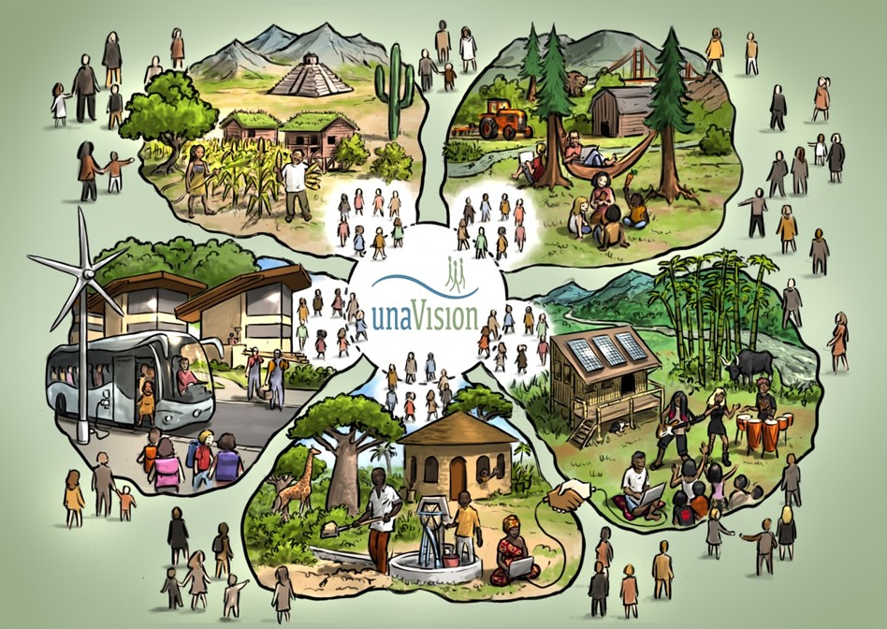**UnaVillage communities and regions** serve as prototypes for resilient, sustainable living, learning, and working together, all with the goal of achieving a fulfilling and content life. These regions host activities of UnaVersity. UnaVillage regions are vibrant communities located in rural areas, where circular economies are developed through eco-social enterprises, food production and processing and a range of learning and cultural activities.

Individuals and teams within these initiatives lead intentional lives, constantly exploring the question "What do I truly, deeply want to do with my life?" Both for themselves and for the benefit of society and nature. They are committed to the ongoing and systematic pursuit of transformative learning and sustainable development aiming at the SDGs.

# UnaVision Partner Search

We are **looking for curious, proactive and motivated partners** - individuals, NGOs, community groups, initiatives, social enterprises, universities or research institutions - who are interested in experimenting with future oriented learning systems and alternative eco-social systems. Partners will join an intercultural team dedicated to co-developing and implementing an alternative learning universe: A system where learners, experts and learning locations can directly connect and create curricula adapted to their needs and their chosen locations.

Furthermore we are **seeking rural locations around the world** where people can work, learn, and live together in experimental ways. These sites should support sustainable practices, including self-sufficient food production and processing, to promote healthy lifestyles. For your information, there is NO funding or financial concept for this initiative at the moment. This will be a task we have to do all together.

Potential partners and participants interested in co-creating, prototyping, and implementing UnaVersity are encouraged to share information with network partners. The program evolves organically as participants form interest groups around specific topics and collaborate with facilitators and experts. Together, they decide on the location, timing and methods for implementing the activities. The coordination teams are forming. They will work in a sociocratic system. This means working in circles that coordinate topics around the UnaVision initiative.

* Join the UnaVision ecosystem platform  
  <https://unavision-network.mn.co/share/Mn-pGHYiPwyT4ODW?utm_source=manual>
* share your profile, offerings, expertise and learning priorities
* participate in regular online and/or physical meetings and become active in working circles

The different roles in our ecosystem are right now:

* Learners - Researchers - Creators
  + People and teams who are creating knowledge, concepts, projects, who are finding what they really like to do and implement it with the support of the
* Experts - Mentors
  + People who like to share their knowledge and experience with the learners and creators
* Physical locations - UnaVillages
  + Facilitators of locations who can welcome individuals and teams of learners and experts to conduct their learning and research activities
* AI System and technology support
  + 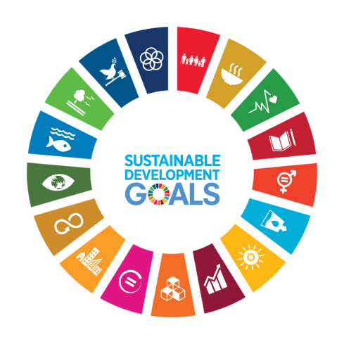People who devote their capacities to create the technological environment to enable UnaVision. The AI system,
* Administrators
  + are creating a lean, efficient and cost effective system
* Supporters - funders
  + Supporting the funding and creation of the UnaVision system with donations
* UnaVision co-creators
  + research for reproducible evidence on UnaVision initiative topics such as future social systems and community development, alternative learning and economic systems …

*ThinkCamp gem. eG, Herzershof 10, 15328 Küstriner Vorland, Germany  
Web:* [*www.thinkcamp.eu*](http://www.thinkcamp.eu) *+* [*www.unavision.eu*](http://www.unavision.eu)[*johannes.pfister@thinkcamp.eu*](mailto:johannes.pfister@thinkcamp.eu) *or* [*frauke.thiel@unavision.eu*](mailto:frauke.thiel@unavision.eu) *Mobile and WhatsApp +49 (172) 862 8947*